VISVESVARAYA TECHNOLOGICAL UNIVERSITY
“JnanaSangama”, Belgaum -590014, Karnataka.


LAB REPORT
On

DATA STRUCTURES (23CS3PCDST)

Submitted by Nalluri Dhanyasri (1BF24CS189)
in partial fulfillment for the award of the degree of BACHELOR OF ENGINEERING
in

COMPUTER SCIENCE AND ENGINEERING


B.M.S. COLLEGE OF ENGINEERING
(Autonomous Institution under VTU) BENGALURU-560019
August-December 2025

B. M. S. College of Engineering,
Bull Temple Road, Bangalore 560019
(Affiliated To Visvesvaraya Technological University, Belgaum) Department of Computer Science and Engineering



This is to certify that the Lab work entitled “DATA STRUCTURES” carried out by Nalluri Dhanyasri (1BF24CS189), who is bonafide student of B. M. S. College of Engineering. It is in partial fulfillment for the award of Bachelor of Engineering in Computer Science and Engineering of the Visvesvaraya Technological University, Belgaum during the year 2025- 2026. The Lab report has been approved as it satisfies the academic requirements in respect of Data structures Lab - (23CS3PCDST) work prescribed for the said degree.

Anusha S Dr. Kavitha Sooda
Assistant Professor Professor and Head
Department of CSE Department of CSE
BMSCE, Bengaluru BMSCE, Bengaluru

Index Sheet

Sl.  No. | Experiment Title | Page No.
1 | Stacks | 4-6
2 | Infix to Postfix | 7-8
3 | - Linear  - Circular Queue | 9-13
4 | - Insertion of Single linked list  - Leetcode | 14-19
5 | - Deletion of Single linked list  - Leetcode | 20-25
6 | a) Sort,Reverse,Concate  b) Stack single linked list | 26-34
7 | - Doubly Linked list  - Leetcode | 35-40
8 | - BST  - Leetcode | 41-46
9 | - BFS  - DFS | 47-49
10 | Hashtable | 50-51

Course outcomes:

CO1 | Apply the concept of linear and nonlinear data structures.
CO2 | Analyze data structure operations for a given problem
CO3 | Design and develop solutions using the operations of linear and nonlinear data structure for a given specification.
CO4 | Conduct practical experiments for demonstrating the operations of different data structures.

Lab program 1:
Write a program to simulate the working of stack using an array with the following:
- Push
- Pop
- Display
The program should print appropriate messages for stack overflow, stack underflow.

#include<stdio.h>
#define N 5
int stack[N];
int top=-1;

void push(){
if(top==N-1){
printf("Stack Overflow\n");
return;
}else{
int x;
printf("Enter the element to be pushed: ");
scanf("%d",&x);
top++;
stack[top]=x;
printf("Pushed Element:%d \n",stack[top]);
}
}

void pop(){
if(top==-1){
printf("Stack underflow\n");
return;
}else{
int item=stack[top];
top--;
printf("Popped element: %d \n",item);
}
}

void peek(){
if (top==-1)
{
printf("Stack is Empty\n");
return;
} else{
printf("Peek element of stack: %d \n",stack[top]);
}
}

void display(){
if(top==-1){
printf("Stack is Empty\n");
return;
}else{
for(int i=0;i<=top;i++){
printf("%d ",stack[i]);
}
}
printf("\n");
}

int main(){
int choice;
while(1){
printf("1.Insert\n2.Delete\n3.Peek\n4.Display\n");
printf("Enter the choice: ");
scanf("%d",&choice);

switch (choice){
case 1:
push();
break;
case 2:
pop();
break;
case 3:
peek();
break;
case 4:
display();
break;
default:
printf("Invalid Choice\\n");
break;
}
}
}

Output:
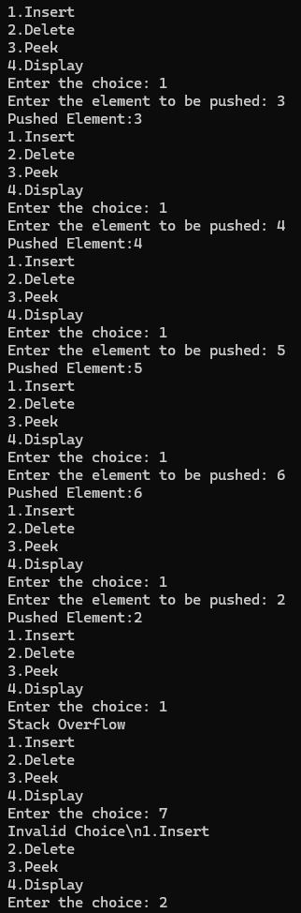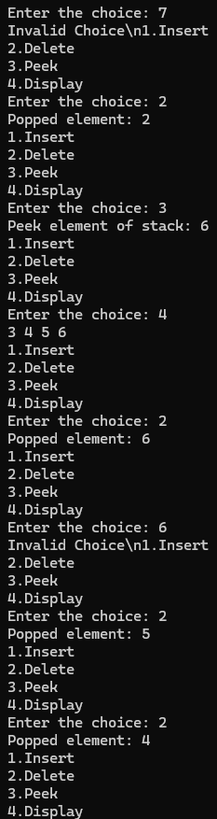
Lab program 2:

WAP to convert a given valid parenthesized infix arithmetic expression to postfix expression. The expression consists of single character operands and the binary operators + (plus), - (minus), * (multiply) and / (divide)

#include<stdio.h>
#include<ctype.h>
#include<string.h>

#define N 100
char stack[N];
int top=-1;

void push(char x){
if(top==N-1){
printf("Stack Overflow\n");
}
else{
stack[++top]=x;
}
}

char pop(){
if(top==-1){
printf("Stack Underflow\n");
}else{
return stack[top--];
}
}

int precendence(char a){
if(a=='^'){
return 3;
}else if(a=='*' || a=='/' || a=='%'){
return 2;
}else if(a=='+' || a=='-'){
return 1;
}else{
return 0;
}
}

int main(){
char infix[N],postfix[N];
int i; int k=0;
char x;

printf("Enter the infix expresssion: ");
gets(infix);

for(i=0;i< strlen(infix);i++){
char ch=infix[i];

if(isalnum(ch)){
postfix[k++]=ch;
}else if(ch=='('){
push(ch);
}else if(ch==')'){
while((x=pop())!='('){
postfix[k++]=x;
}
}
else{
while(precendence(stack[top])>=precendence(ch)){
postfix[k++]=pop();
}
push(ch);
}
}
while(top!=-1){
postfix[k++]=pop();
}
postfix[k]='\0';

printf("The Postfix Expression: %s ",postfix);
return 0;
}

Output:

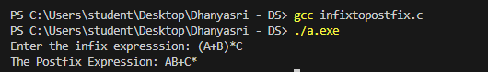
Lab program 3:

- WAP to simulate the working of a queue of integers using an array. Provide the following operations: Insert, Delete, Display The program should print appropriate messages for queue empty and queue overflow conditions

include<stdio.h>
#define MAX 5
int queue_array[MAX];
int rear=-1;
int front=-1;
void insert(){
int add_item;
if (rear==MAX-1)
printf("queue overflow\n");
else{
if (front==-1)
front=0;
printf("insert element in the queue:");
scanf("%d",&add_item);
rear=rear+1;
queue_array[rear]=add_item;
}
}
void delete(){
if(front==-1||front>rear){
printf("queue underflow");
return;
}else{
printf("deleted element is %d\n",queue_array[front]);
front=front+1;
}
}
void display(){
int i;
if(front==-1);
printf("queue is empty\n");
else{
printf("queue elements are :\n");
for(i=front;i<=rear;i++)

printf("%d",queue_array[i]);
printf("\n");
}
}
int main(){
int choice;
while(1){
printf("\n 1. insert\n 2. delete\n 3. display\n 4. exit\n");
printf("enter your choice:");
scanf("%d",&choice);
switch (choice){
case 1: insert();
break;
case 2: delete();
break;
case 3: display();
break;
case 4: return 0;
default: printf("inavlid choice\n");
}
}
}
Output:
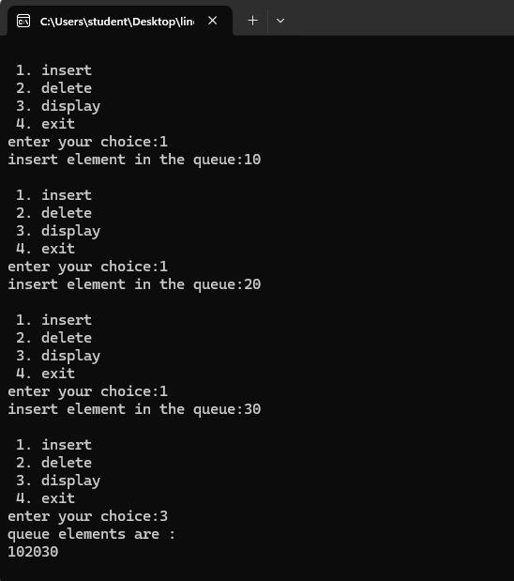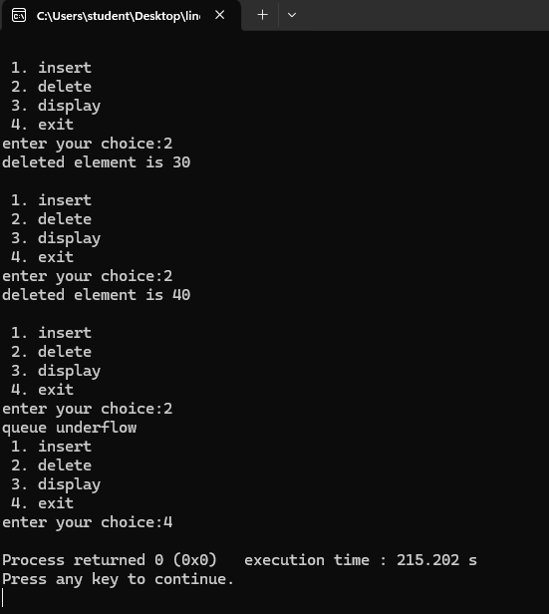

b) WAP to simulate the working of a circular queue of integers using an array. Provide the following operations: Insert, Delete & Display The program should print appropriate messages for queue empty and queue overflow conditions

#include <stdio.h>
#define SIZE 5

int queue[SIZE];
int front = -1, rear = -1;

int isFull() {
return (front == 0 && rear == SIZE - 1) || (front == rear + 1);
}
int isEmpty() {
return (front == -1);
}
void enQueue(int element) {
if (isFull()) {
printf("\nQueue is full!\n");
} else {
if (front == -1)
front = 0;
rear = (rear + 1) % SIZE;
queue[rear] = element;
printf("\nInserted -> %d\n", element);
}
}

void deQueue() {
if (isEmpty()) {
printf("\nQueue is empty!\n");
} else {
printf("\nDeleted -> %d\n", queue[front]);
if (front == rear) {
front = rear = -1;
} else {
front = (front + 1) % SIZE;
}
}
}

void display() {
int i;
if (isEmpty()) {
printf("\nQueue is empty!\n");
} else {
printf("\nFront -> %d", front);
printf("\nItems -> ");
for (i = front; i != rear; i = (i + 1) % SIZE)
printf("%d ", queue[i]);
printf("%d ", queue[i]);
printf("\nRear -> %d\n", rear);
}
}

int main() {
int choice, element;

while (1) {
printf("\n\n--- Circular Queue Menu ---");
printf("\n1. Insert (Enqueue)");
printf("\n2. Delete (Dequeue)");
printf("\n3. Display");
printf("\n4. Exit");
printf("\nEnter your choice: ");
scanf("%d", &choice);
switch (choice) {
case 1:
printf("Enter element to insert: ");
scanf("%d", &element);
enQueue(element);
break;
case 2:
deQueue();
break;
case 3:
display();
break;
case 4:
printf("\nExiting program...\n");

return 0;
default:
printf("\nInvalid choice! Try again.\n");
}
}
}

Output:
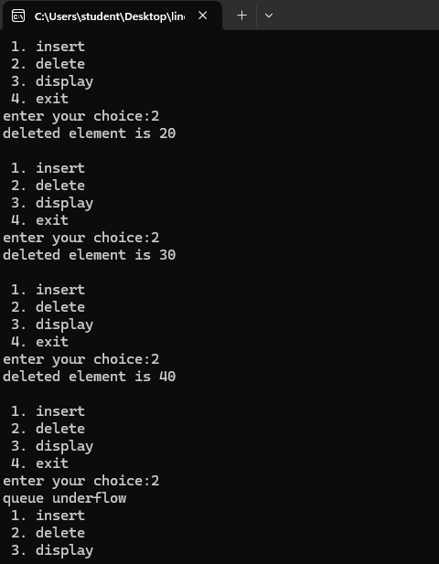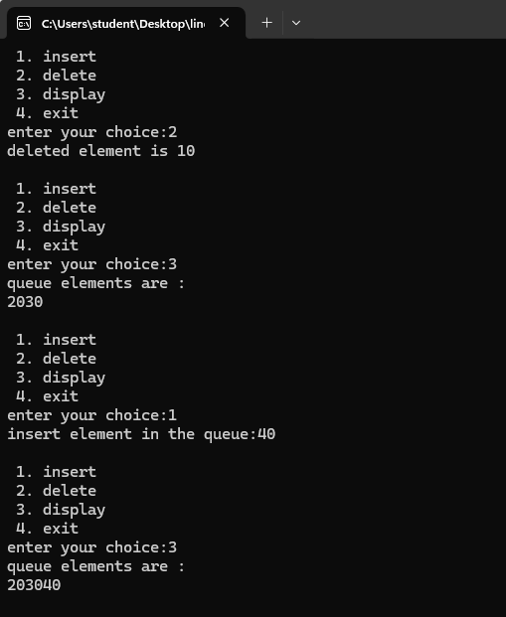

Lab program 4:

a) WAP to Implement Singly Linked List with following operations
a) Create a linked list.
b) Insertion of a node at first position, at any position and at end of list. Display the contents of the linked list.

#include <stdio.h>
#include <stdlib.h>
struct Node{
int data;
struct Node *next;
};
struct Node *head=NULL;
void create(int n){
struct Node *newNode, *temp;
int data,i;
if (n<=0){
printf("No of nodes should be greater than zero");
return;
}
for (i=1;i<=n;i++){
newNode=(struct Node*)malloc(sizeof(struct Node));
if (newNode==NULL){
printf("failed to allocate memory\n");
return;
}
printf("Enter data\n");
scanf("%d",&data);
newNode->data=data;
newNode->next=NULL;

if (head==NULL){
head=newNode;
}else {
temp->next=newNode;
}
temp = newNode;
}
printf("created successfully\n");

}
void insertBeginning( int data){
struct Node *newNode=(struct Node*)malloc(sizeof(struct Node));
newNode->data=data;
newNode->next=head;
head=newNode;
printf("successfully inserted at begining\n");
}
void insertEnd(int data){
struct Node *newNode=(struct Node*)malloc(sizeof(struct Node));
newNode->data=data;
newNode->next=NULL;

if (head==NULL){
head=newNode;
}else{
struct Node *temp=head;
while(temp->next!=NULL) temp=temp->next;
temp->next=newNode;
}
printf("successfully inserted at end\n");
}
void insert(int data, int pos){
int i;
struct Node *newNode,*temp=head;
if (pos<1){
printf("invalid pos\n"); return;
}
if (pos==1){
insertBeginning(data);
return;
}
newNode=(struct Node*)malloc(sizeof(struct Node));
newNode->data=data;

for (i=1;i<pos-1 && temp!=NULL; i++){
temp=temp->next;
}
if (temp==NULL){
printf("Position out of range\n");

free(newNode);
}else{
newNode->next=temp->next;
temp->next=newNode;
printf("successfully inserted at posiiton\n");
}
}
void display(){
struct Node *temp=head;
if (head=NULL){
printf("list empty\n");
return;
}
printf("list: \n");
while (temp!=NULL){
printf("%d ->",temp->data);
temp=temp->next;
}
printf("NULL");
}
int main(){
int ch,n,data,pos;

while(1){
printf("\nChoose your option:\n 1. create\n 2. insert at beginning\n 3. insert at end\n 4. insert at any position\n 5. display\n 6. exit\n");
scanf("%d", &ch);

switch (ch){
case 1:
printf("Enter no of nodes: ");
scanf("%d", &n);
create(n);
break;
case 2:
printf("Enter data: ");
scanf("%d", &data);
insertBeginning(data);
break;

case 3:
printf("Enter data: ");
scanf("%d", &data);
insertEnd(data);
break;
case 4:
printf("Enter data and pos: ");
scanf("%d %d", &data, &pos);
insert(data,pos);
break;
case 5:
display();
break;
case 6:
exit(0);
default:
printf("Invalid choice");
}
}
return 0;
}

Output:

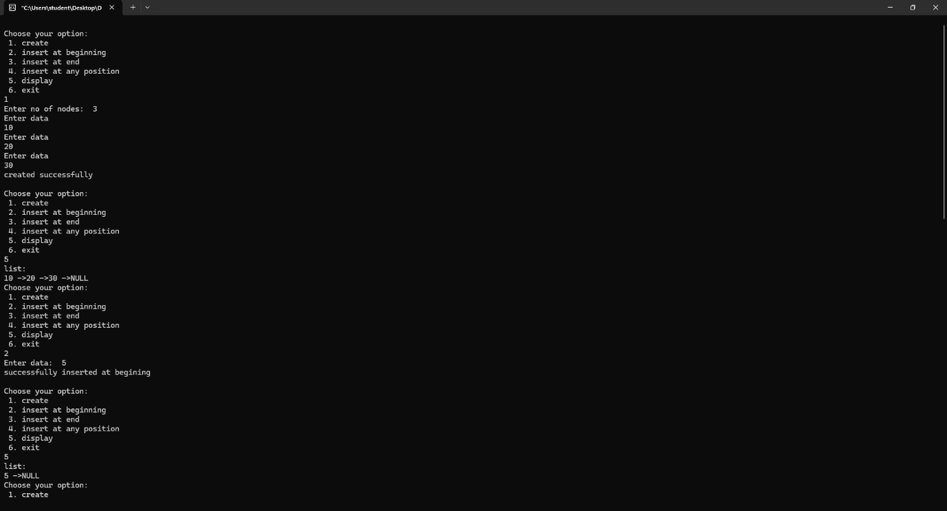

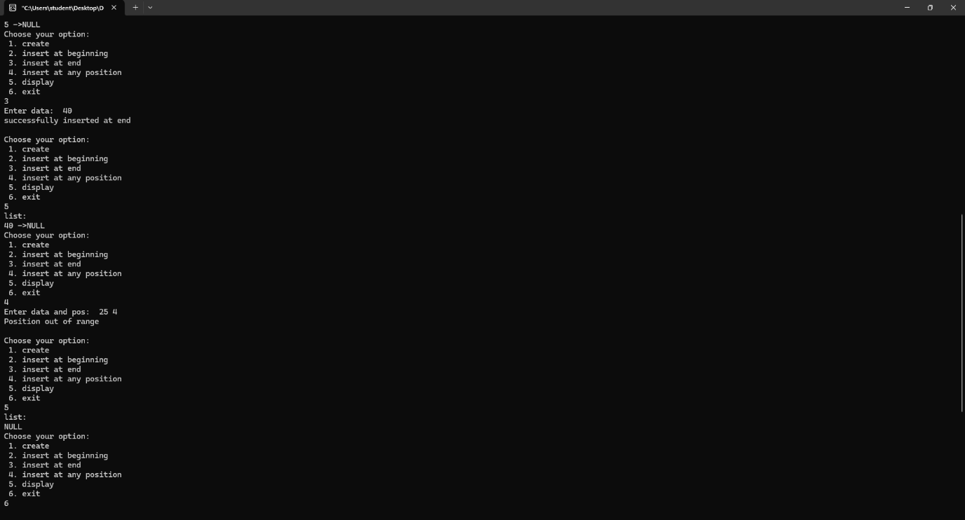

4b) Leetcode platform
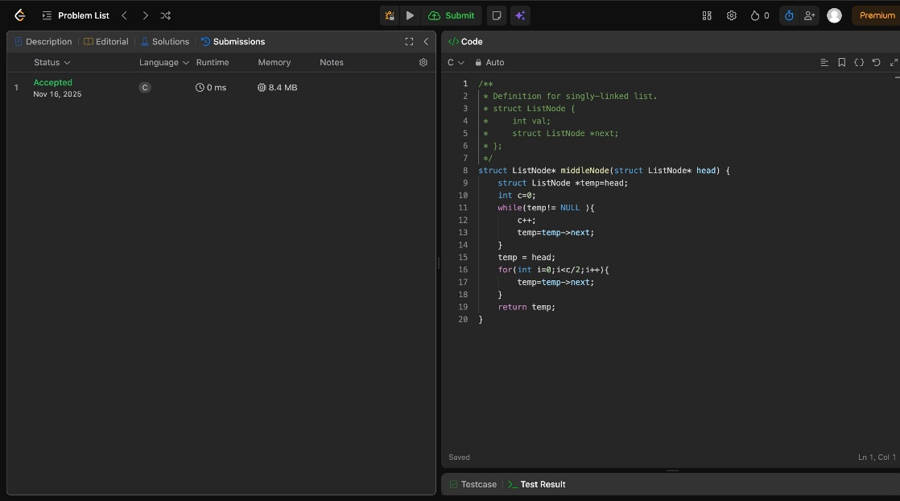

Lab program 5:

- WAP to Implement Singly Linked List with following operations a) Create a linked list. b) Deletion of first element, specified element and last element in the list. c) Display the contents of the linked list.

#include<stdio.h>
struct node{
int data;
struct node *next;
}*head=NULL;
int count()
{
struct node *temp;
int i=1;
temp=head;
while(temp->next!= NULL)
{
temp=temp->next;
i++;
}
return(i);
}
struct node*create(int value)
{
struct node *temp;
temp=(struct node*)malloc(sizeof(struct node));
if(temp==NULL)
{
printf("memory allocation failed");
exit(0);
}
else{
temp->data=value;
temp->next=NULL;
}
return temp;
}
void insert_begin(int value)
{
struct node*newnode;
newnode=create(value);
if(head==NULL)
{
head=newnode;
}
else{
newnode->next=head;
head=newnode;
}
}
void insert_end(int value)
{
struct node*newnode,*temp;
newnode=create(value);
if(head==NULL)
{
head=newnode;
}
else
{
while(temp->next!=NULL)
{
temp=temp->next;
}
temp->next=newnode;
}
}
void insert_pos(int value,int pos)
{
struct node*newnode,*temp1,*temp2;
newnode=create(value);
int i=count();
int c=1;
if(pos==1)
{
insert_begin(value);
}
else if(pos>i+1)
{
printf("insertion is not possible\n");
return;
}
else{
temp1=head;
while(c<=pos-1&&temp1 !=NULL)
{
temp2=temp1;
temp1=temp1->next;
c++;
}
newnode->next=temp2->next;
temp2->next=newnode;
}
}
void delete_begin()
{
struct node *temp;
if(head==NULL)
{
printf("deletion is not possible");
}
else
{
temp=head;
head=head->next;
free(temp);
}
}
void delete_end()
{
struct node *temp1,*temp2;
if(head==NULL)
{
printf("deletion is not possible");
}
else
{
temp1=head;
while(temp1->next!=NULL){
temp2=temp1;
temp1=temp1->next;
}
temp2->next=NULL;
free(temp1);
}
}
void delete_spec_value(int key)
{
if (head == NULL){
printf("List is empty. Cannot delete.\n");
return;
}
struct node *temp1 = head;
struct node *temp2 = NULL;
if (temp1 != NULL && temp1->data == key){
head = temp1->next;
free(temp1);
printf("Element %d deleted.\n", key);
return;
}
while (temp1 != NULL && temp1->data != key){
temp2 = temp1;
temp1 = temp1->next;
}
if (temp1 == NULL){
printf("Element %d not found in the list.\n", key);
return;
}
temp2->next = temp1 ->next;
free(temp1);
printf("Element %d deleted.\n", key);
}
void display()
{
struct node*temp;
if(head==NULL){

printf("list is empty");
}
else{
temp=head;
while(temp->next!=NULL)
{
printf("%d->",temp->data);
temp=temp->next;
}
printf("%d\n",temp->data);
}
}
void main()
{
int ch,pos,value,key;
printf("\n1.insert begin \n2.insert end \n3.insert at given position \n4.delete begin \n5.delete end \n6.delete given value \n7.display \n8.exit\n");
do{
printf("Enter the choice:");
scanf("%d",&ch);
switch(ch)
{
case 1:
{
printf("Enter the value:");
scanf("%d",&value);
insert_begin(value);
break;
}
case 2:
{
printf("Enter the value:");
scanf("%d",&value);
insert_end(value);
break;
}
case 3:
{
printf("Enter the pos and value:");
scanf("%d %d",&pos,&value);
insert_pos(value,pos);
break;
}
case 4: delete_begin();
break;
case 5: delete_end();
break;
case 6: {printf("enter key value of a node you want to delete: ");
scanf("%d",&key);
delete_spec_value (key);
break;
}
case 7:
display();
break;
case 8:
break;
default: printf("\n your choice is wrong!...");
}
}while(ch!=8);
}

Output:
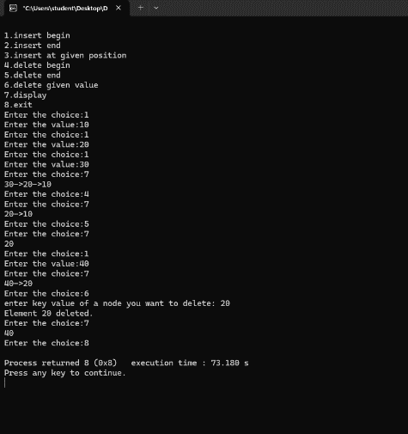
5b) Leetcode platform

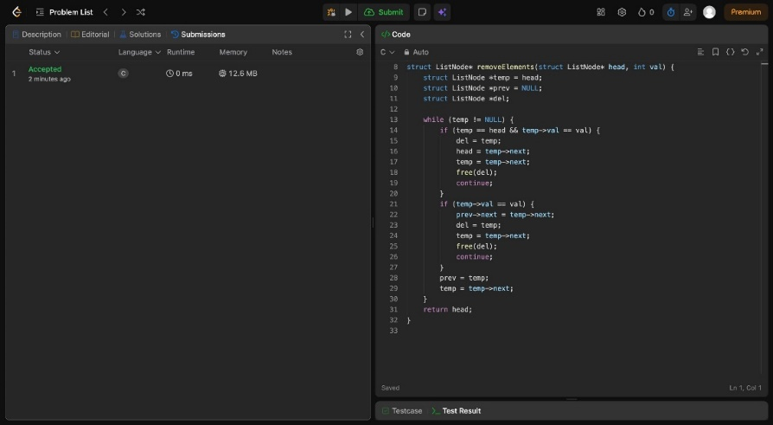

Lab program 6:

- WAP to Implement Single Link List with following operations: Sort the linked list, Reverse the linked list, Concatenation of two linked lists.

#include <stdio.h>
#include <stdlib.h>
struct Node {
int data;
struct Node *next;
};

struct Node* insertEnd(struct Node *head, int value) {
struct Node *newNode = (struct Node*)malloc(sizeof(struct Node));
newNode->data = value;
newNode->next = NULL;

if (head == NULL)
return newNode;

struct Node *temp = head;
while (temp->next != NULL)
temp = temp->next;

temp->next = newNode;
return head;
}

void display(struct Node *head) {
while (head != NULL) {
printf("%d -> ", head->data);
head = head->next;
}
printf("NULL\n");
}

void sortList(struct Node *head) {
struct Node *i, *j;
int temp;
for (i = head; i != NULL; i = i->next) {

for (j = i->next; j != NULL; j = j->next) {
if (i->data > j->data) {
temp = i->data;
i->data = j->data;
j->data = temp;
}
}
}
}

struct Node* reverseList(struct Node *head) {
struct Node *prev = NULL, *curr = head, *next = NULL;

while (curr != NULL) {
next = curr->next;
curr->next = prev;
prev = curr;
curr = next;
}
return prev;
}

struct Node* concatenate(struct Node *head1, struct Node *head2) {
if (head1 == NULL) return head2;
if (head2 == NULL) return head1;

struct Node *temp = head1;

while (temp->next != NULL)
temp = temp->next;

temp->next = head2;
return head1;
}

int main() {
struct Node *head1 = NULL, *head2 = NULL;
int n, val;

printf("Enter number of nodes in List1: ");
scanf("%d", &n);

printf("Enter elements of List1:\n");
for (int i = 0; i < n; i++) {
scanf("%d", &val);
head1 = insertEnd(head1, val);
}

printf("\nEnter number of nodes in List2: ");
scanf("%d", &n);

printf("Enter elements of List2:\n");
for (int i = 0; i < n; i++) {
scanf("%d", &val);
head2 = insertEnd(head2, val);
}

printf("\nList1: ");
display(head1);

printf("List2: ");
display(head2);

printf("\nSorted List1: ");
sortList(head1);
display(head1);

printf("Reversed List1: ");
head1 = reverseList(head1);
display(head1);

printf("Concatenated List: ");
head1 = concatenate(head1, head2);
display(head1);
return 0;
}

Output:

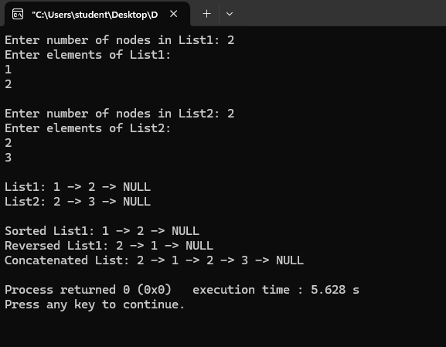

b) WAP to Implement Single Link List to simulate Stack & Queue Operations.

#include <stdio.h>
#include <stdlib.h>
struct Node {
int data;
struct Node *next;
};

struct Node *head = NULL;

void push(int value) {
struct Node *newNode = (struct Node*)malloc(sizeof(struct Node));
newNode->data = value;
newNode->next = head; // insert at beginning
head = newNode;
printf("Pushed %d\n", value);
}

void pop() {
if (head == NULL) {
printf("Stack Underflow\n");
return;
}
struct Node *temp = head;
head = head->next;
printf("Popped %d\n", temp->data);
free(temp);
}

void enqueue(int value) {
struct Node *newNode = (struct Node*)malloc(sizeof(struct Node));
newNode->data = value;
newNode->next = NULL;

if (head == NULL) { // empty queue
head = newNode;
} else {
struct Node *temp = head;
while (temp->next != NULL)
temp = temp->next;
temp->next = newNode;
}
printf("Enqueued %d\n", value);
}

void dequeue() {
if (head == NULL) {
printf("Queue Underflow\n");
return;
}
struct Node *temp = head;
head = head->next;
printf("Dequeued %d\n", temp->data);
free(temp);
}
void display() {
struct Node *temp = head;
printf("List: ");
while (temp != NULL) {
printf("%d ", temp->data);
temp = temp->next;
}
printf("\n");
}
int main() {
int choice, value;
while (1) {
printf("\n1.Push\n2.Pop\n3.Enqueue\n4.Dequeue\n5.Display\n6.Exit\n");
scanf("%d", &choice);
switch (choice) {
case 1: printf("Enter value: "); scanf("%d", &value); push(value); break;
case 2: pop(); break;
case 3: printf("Enter value: "); scanf("%d", &value); enqueue(value); break;
case 4: dequeue(); break;
case 5: display(); break;
case 6: exit(0);
default: printf("Invalid choice\n");
}
}
}

Output:

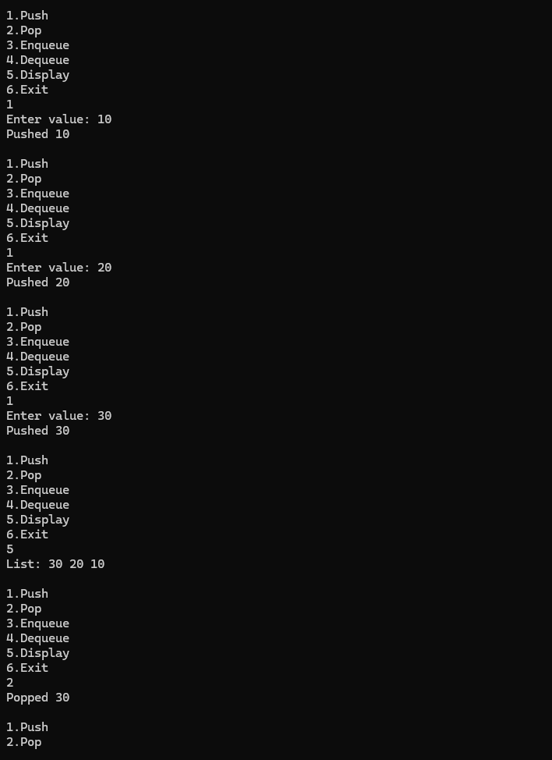
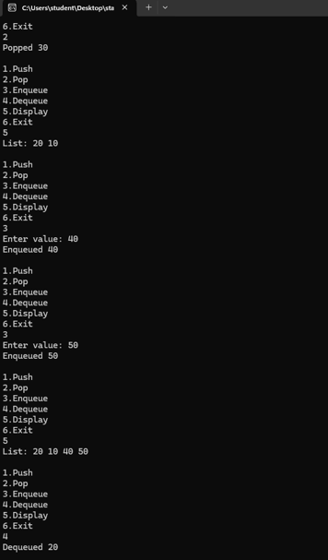
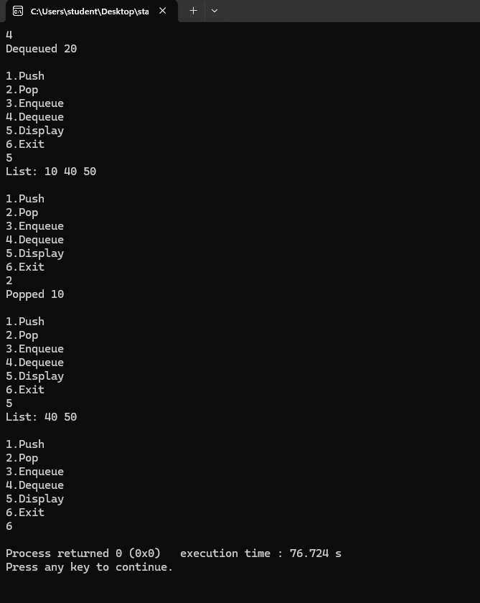

Lab program 7:

WAP to Implement doubly link list with primitive operations
a) Create a doubly linked list.
b) Insert a new node to the left of the node.
c) Delete the node based on a specific value
d) Display the contents of the list

#include<stdio.h>
#include<stdlib.h>
struct node{
int data;
struct node *prev,*next;
};
struct node *head=NULL;
struct node *tail=NULL;

struct node *createnode(int value){
struct node *new=(struct node*)malloc(sizeof(struct node));
new->data=value;
new->prev=new->next=NULL;
return new;
}

void insertfront(int value){
struct node *new=createnode(value);
if(head==NULL){
head=tail=new;
return;
}
new->next=head;
head->prev=new;
head=new;
}

void insertend(int value){
struct node *new=createnode(value);
if(tail==NULL){
head=tail=new;
return;
}
tail->next=new;
new->prev=tail;
tail=new;
}
void deletebyvalue(int value){
if(head==NULL)
return;
struct node *temp=head;
while(temp!=NULL && temp->data!=value)
temp=temp->next;
if(temp==NULL)
return;
if(temp==head){
head=head->next;
if(head!=NULL) head->prev=NULL;
else tail=NULL;
free(temp);
return;
}
if(temp==tail){
tail=tail->prev;
tail->next=NULL;
free(temp);
return;
}
temp->prev->next=temp->next;
temp->next->prev=temp->prev;
free(temp);
}
void deletebyposition(int pos){
if(head==NULL || pos<=0)
return;
struct node *temp=head;
int i=1;
while(temp!=NULL && i<pos){
temp=temp->next;
i++;
}
if(temp=NULL)return;
if(temp==head){

head=head->next;
if(head!=NULL)
head->prev=NULL;
else tail=NULL;
free(temp);
return;
}
temp->prev->next=temp->next;
temp->next->prev=temp->prev;
free(temp);
}
void display(){
struct node *temp=head;
printf("list: ");
while(temp!=NULL){
printf("%d",temp->data);
temp=temp->next;
}
printf("\n");
}

int main() {
int choice, value, pos;

while (1) {
printf("\n1.Insert Front\n2.Insert End\n3.Delete by Value\n4.Delete by Position\n5.Display\n6.Exit\n");
printf("enter choice: ");
scanf("%d", &choice);
switch (choice) {
case 1:
printf("Enter value: ");
scanf("%d", &value);
insertfront(value);
break;
case 2:
printf("Enter value: ");
scanf("%d", &value);
insertend(value);
break;

case 3:
printf("Enter value: ");
scanf("%d", &value);
deletebyvalue(value);
break;

case 4:
printf("Enter position: ");
scanf("%d", &pos);
deletebyposition(pos);
break;

case 5:
display();
break;

case 6:
exit(0);

default:
printf("Invalid choice\n");
}
}
}

Output:
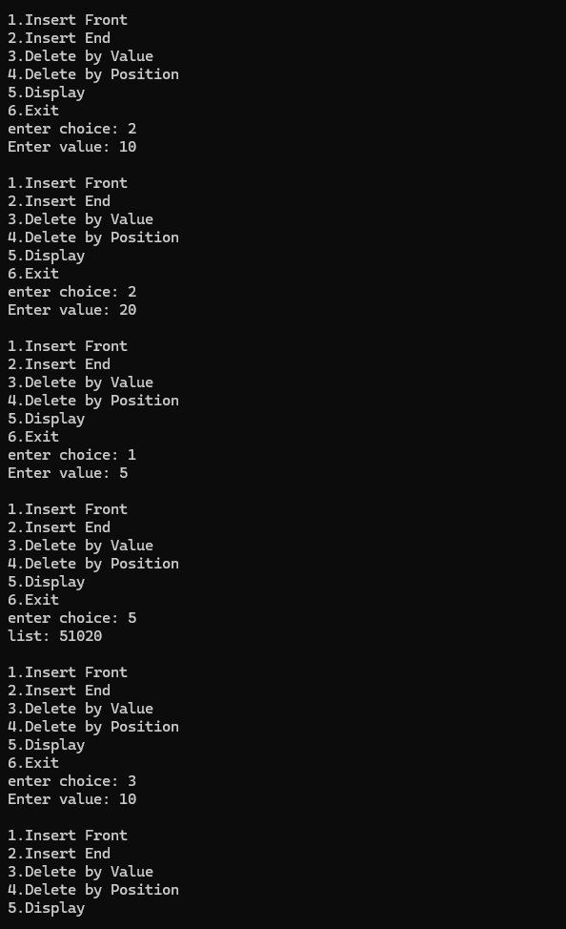

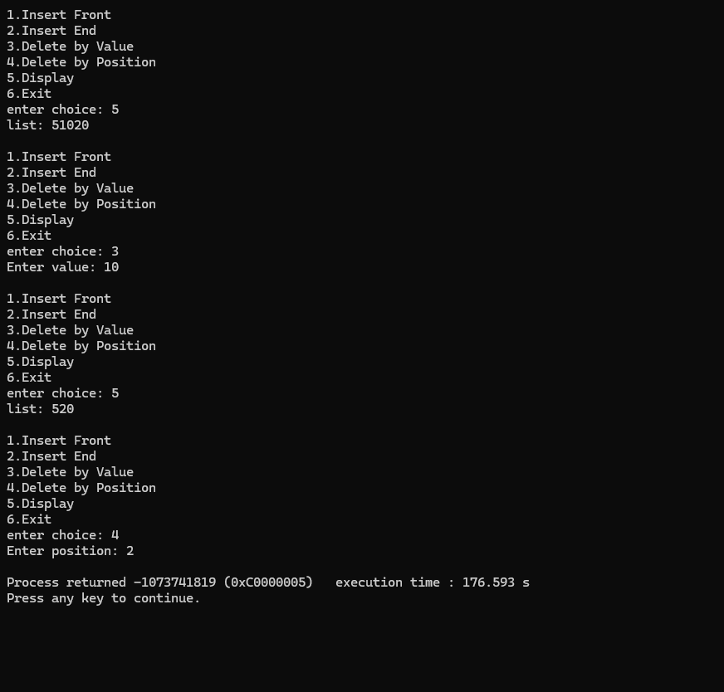

- Leetcode platform

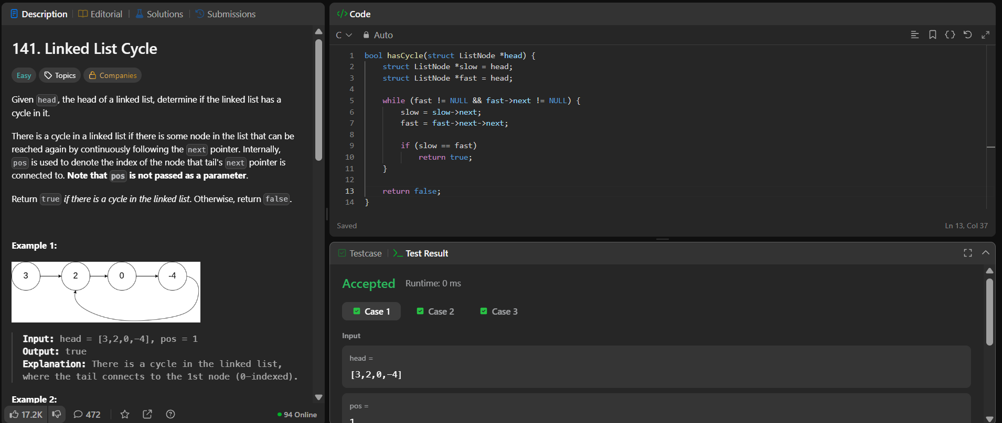

Lab program 8:

Write a program a) To construct a binary Search tree.
b) To traverse the tree using all the methods i.e., in-order, preorder and post order
c) To display the elements in the tree.
#include <stdio.h>
#include <stdlib.h>

struct node {
int data;
struct node *left, *right;
};

struct node* createnode(int value) {
struct node* newnode = (struct node*)malloc(sizeof(struct node));
newnode->data = value;
newnode->left = newnode->right = NULL;
return newnode;
}

struct node* insert(struct node *root, int value) {
if (root == NULL)
return createnode(value);

if (value < root->data)
root->left = insert(root->left, value);
else if (value > root->data)
root->right = insert(root->right, value);

return root;
}

void inorder(struct node *root) {
if (root == NULL)
return;
inorder(root->left);
printf("%d ", root->data);
inorder(root->right);
}

void preorder(struct node *root) {
if (root == NULL)
return;
printf("%d ", root->data);
preorder(root->left);
preorder(root->right);
}

void postorder(struct node *root) {
if (root == NULL)
return;
postorder(root->left);
postorder(root->right);
printf("%d ", root->data);
}

void display(struct node *root) {
printf("Elements (inorder): ");
inorder(root);
printf("\n");
}

int main() {
struct node *root = NULL;
int choice, value;

while (1) {
printf("\n1. insert into BST\n");
printf("2. inorder traversal\n");
printf("3. preorder traversal\n");
printf("4. postorder traversal\n");
printf("5. display BST\n");
printf("6. exit\n");
printf("enter choice: ");
scanf("%d", &choice);

switch (choice) {
case 1:
printf("Enter value: ");
scanf("%d", &value);
root = insert(root, value);
break;

case 2:
printf("Inorder traversal: ");
inorder(root);
printf("\n");
break;

case 3:
printf("Preorder traversal: ");
preorder(root);
printf("\n");
break;

case 4:
printf("Postorder traversal: ");
postorder(root);
printf("\n");
break;

case 5:
display(root);
break;

case 6:
exit(0);

default:
printf("Invalid choice\n");
}
}

return 0;
}

Output:

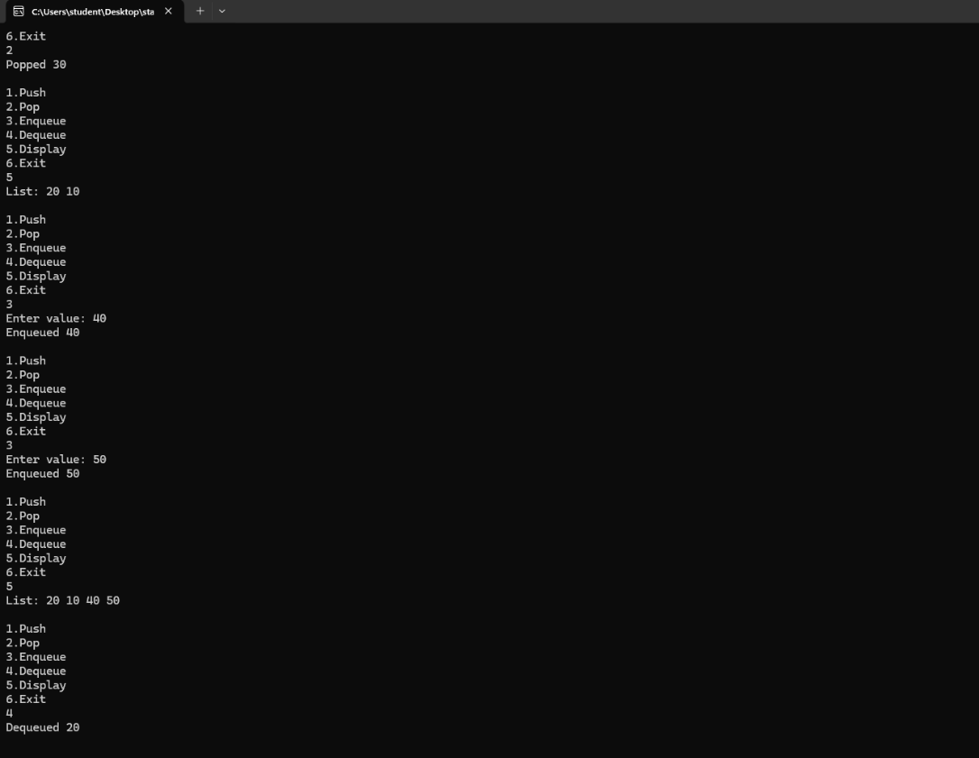

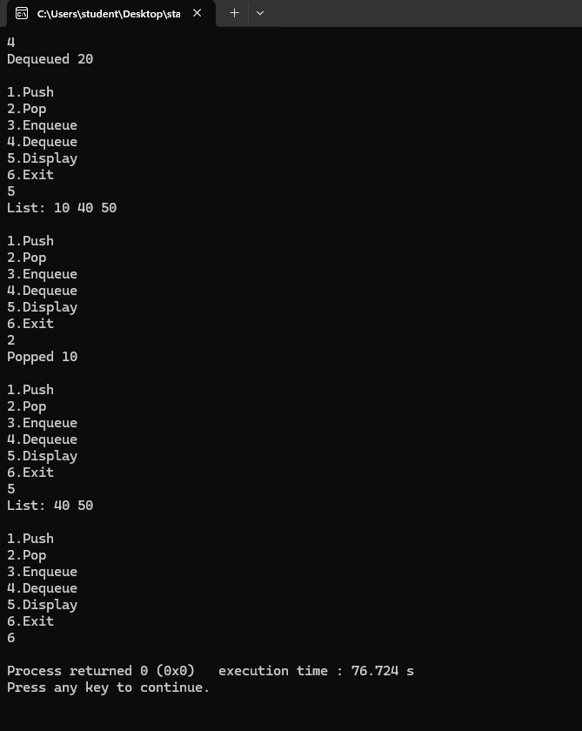

b) Leetcode platform

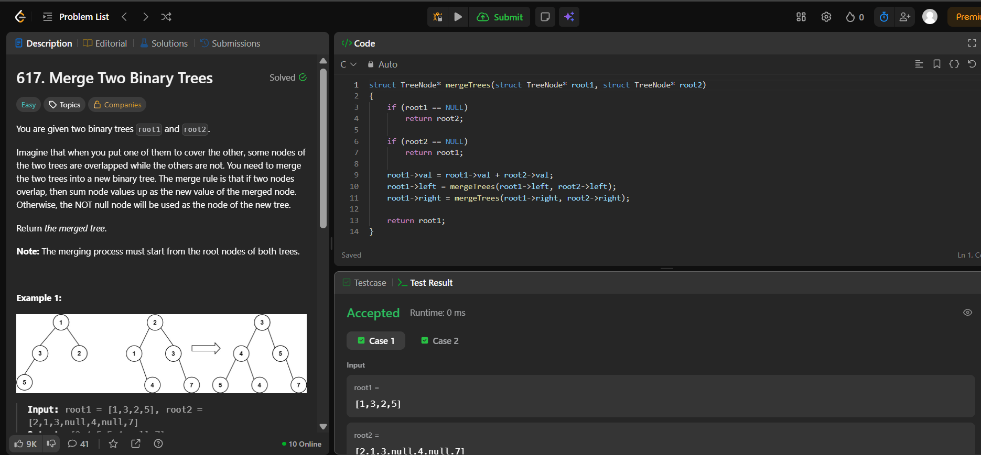

Lab program 9:

- Write a program to traverse a graph using BFS method

#include<stdio.h>
int graph[20][20],visited[20],n;
void BFS (int start){
int queue[20],front=0,rear=0;
visited[start]=1;
queue[rear++]=start;
while(front<rear){
int node=queue[front++];
printf("%d ",node);
for(int i=0;i<n;i++){
if(graph[node][i]==1 && !visited[i]){
visited[i]=1;
queue[rear++]=i;
}
}
}
}
int main(){
int start;
printf("enter the number of vertices: ");
scanf("%d",&n);
printf("adjacency matrix is:");
for(int i=0;i<n;i++)
for(int j=0;j<n;j++)
scanf("%d",&graph[i][j]);
for(int i=0;i<n;i++)
visited[i]=0;
printf("enter starting vertex: ");
scanf("%d",&start);
printf("BFS traversal: ");
BFS(start);
return 0;
}

Output:
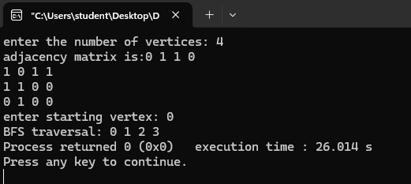

- Write a program to check whether given graph is connected or not using DFS method.

#include<stdio.h>
#define MAX 10
int visited[MAX];
int adj[MAX][MAX];
int n;
void DFS(int v){
visited[v]=1;
printf("%d",v);
for(int i=0;i<n;i++){
if(adj[v][i]==1 && !visited[i]){
DFS(i);
}
}
}
int main(){
printf("enter the number of vertices: ");
scanf("%d",&n);
printf("adjacency matrix is:");
for(int i=0;i<n;i++)
for(int j=0;j<n;j++)
scanf("%d",&adj[i][j]);
for(int i=0;i<n;i++)
visited[i]=0;
printf("DFS traversal: ");
DFS(0);
return 0;
}

Output:
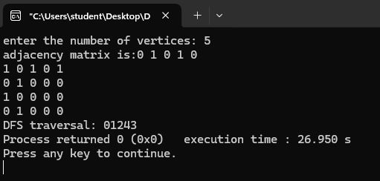

Lab program 10:

Given a File of N employee records with a set K of Keys(4- digit) which uniquely determine the records in file F. Assume that file F is maintained in memory by a Hash Table (HT) of m memory locations with L as the set of memory addresses (2-digit) of locations in HT. Let the keys in K and addresses in L are integers. Design and develop a Program in C that uses Hash function H: K -> L as H(K)=K mod m (remainder method), and implement hashing technique to map a given key K to the address space L. Resolve the collision (if any) using linear probing

#include <stdio.h>
#define MAX 20

int hashtable[MAX];
int m;

void insert(int key) {
int index = key % m;

for (int i = 0; i < m; i++) {
int probe = (index + i) % m;
if (hashtable[index] == -1) {
hashtable[index] = key;
return;
}
}
}

void display() {
printf("\nHash table:\n");
for (int i = 0; i < m; i++) {
if (hashtable[i] != -1)
printf("Address %d: %d\n", i, hashtable[i]);
else
printf("Address %d: empty\n", i);
}
}
int main() {
int n, key;
printf("Enter the size of hash table (max %d): ", MAX);
scanf("%d", &m);
if (m > MAX) {
printf("Size exceeds maximum limit.\n");
return 1;

}
for (int i = 0; i < m; i++) {
hashtable[i] = -1;
}
printf("Enter the number of employee records: ");
scanf("%d", &n);
for (int i = 0; i < n; i++) {
printf("Enter key: ");
scanf("%d", &key);
insert(key);
}
display();
return 0;
}

Output:
